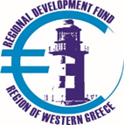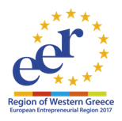
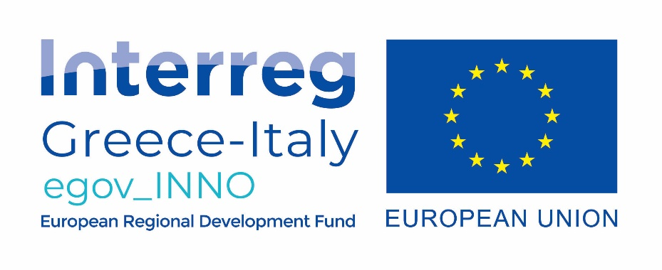
DEVELOPMENT / MATURITY OF BUSINESS PLANS IN THE FRAMEWORK OF THE EGOV_INNO / GREECE-ITALY PROJECT 2014-2020

INVITATION TO SUBMIT PROPOSALS
(end date 22-10-2020 and time 15:00)

The Regional Development Fund of the Region of Western Greece and the Computer Technology Institute and Press "DIOPHNTUS" organize an online event on the development of business plans in the framework of the European project EGOV_INNO of the Greece - Italy Program 2014-2020.

This event gives young and existing entrepreneurs the opportunity to submit their business plan through the project platform and receive comments and advice from experts in the business and academia.

Anyone interested in verifying their business plan before submitting it to a funding body or program has the opportunity to submit this plan to the platform developed in the framework of the EGOV_INNO project and which is located on the web portal www.egovinno.rdfrwg .gr, and specifically by selecting "Toolbox" from the menu and then the "Business Plan Guide".

In this platform, through an automated process of eight (8) steps, the interested party is guided by the application to fill in the necessary fields for the completion of his business plan. At the end it is possible to produce a "Pdf" file which must save it and submit it electronically to ptapde@ptapde.gr with the subject of the message "BUSINESS PLAN FOR THE PROJECT EGOV_INNO".

On the same platform it is possible to attend specific "micro-courses" on issues related to the development of the initial business plan (see menu "Courses" in the "Toolbox" of the project platform).

The deadline for submitting business plans is October 22, 2020 at 15:00 and the submission will be done exclusively by sending the pdf file to the email address: ptapde@ptapde.gr. Business plans submitted in a different way and without the use of the above tool will not be considered.

The event will take place on Tuesday 27 October 2020 via the internet. There, interested parties will be invited to present their idea within five minutes and then they will accept the comments and advice of the jury.

On the same day and in the next session the participants and other interested parties will have the opportunity to attend corresponding initiatives of the Region and other local bodies to strengthen entrepreneurship and support business ideas.

The url of the event and the program will be announced soon on the website of the Regional Development Fund of the Region of Western Greece (www.ptapde.gr) as well as on the website of the EGOV_INNO project (www.interregegovinno.eu).

The EGOV_INNO project is coordinated by the Regional Development Fund of Western Greece, while from Western Greece participates the Institute of Computer Technology Institute and Press "DIOPHNTUS", and from the Italian side the Region of Puglia and the development company INNOVAPUGLIA.

The main goal of the project is the development of e-government services and tools by regional authorities and regional development agencies to support and coordinate the regional potential of research, innovation and entrepreneurship.

For more information, interested parties can contact +302613613651 and +302613613670 (Mr. Tzomakas and Mr. Papachristopoulos) or email gpapantonis@ptapde.gr (Mr. Papantonis).

